**grep Assignment**

Mandatory:

1. Use any .c file. Using grep command extract and display

a. all lines beginning with #include with line numbers

* grep -n '^#include' assignment.c

This command will display all lines that begin with #include and show the line numbers

b. display all lines which do not begin with #include

* grep -n -v '^#include' assignment.c

This command will show all lines that do not start with #include and show the line numbers.

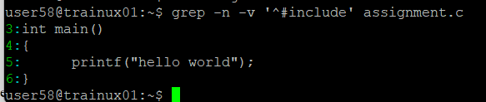

c. display the line number of main()

* grep -n 'main' assignment.c

This command will display the line number of the main() function.

d. extract all lines containing characters of opening and closing parathesis {(,)}

* grep -n '[(){},]' assignment.c

This command will display lines that contain any of the following characters: {, }, (, )

2. Performing the Above Operations on a Set of *.c Files

a. All Lines Beginning with #include with Line Numbers

* grep -n '^#include' *.c

b . Display All Lines Which Do Not Begin with #include

* grep -n -v '^#include' *.c

c. Line Number of main():

* grep -n 'main(' *.c

d. All Lines Containing {, }, (, ), or ,:

* grep -n '[(){},]' *.c

